**Challenge 15**

[www.pythonchallenge.com/pc/return/uzi.html](http://www.pythonchallenge.com/pc/return/uzi.html)

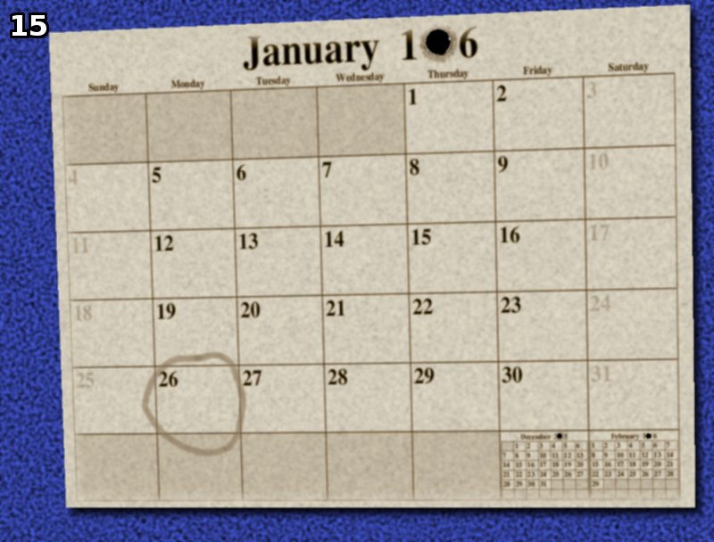

I really like calendar stuff. So, I hoped that would pay off. (it does – this one is not too badd) But first check the basics. Page title is ‘whom?’ and clues is ‘<!-- he ain't the youngest, he is the second -->’ ‘<!-- todo: buy flowers for tomorrow -->’

Also the .jpg for the calendar I thought maybe youngest referred to the little cat in the cat picture, but decided it must be some famous person’s birthday we’re looking for. And it’s on the 27th (because of buy flowers tomorrow. It’s hard to see, but if you look at the little February, there’s the 29th – so whatever year we’re looking for is a leap year.

So, first find all the leap years 1006-1996. Easy with **calendar** module.

There are 5 of them. Googling ‘famous birthday January 27’ leads right to Mozart and it’s in 1756 which is the next to last in the list of leap years.